**Heterogeneity in lobar and near-acini deposition of inhaled aerosol in the mouse lung**

Wanjun Gu1, C. Darquenne1*,

1Department of Medicine, University of California, San Diego, USA

**Abstract:**

Laboratory animals are often used to derive health risk from environmental exposure. To do so, it is important to measure not only the total dose of deposited particulates but also their spatial distribution in the lung. A unique database including both high resolution lung anatomy and deposition data in four strains of mice have been recently made available to the research community (Lung anatomy + particle deposition (LAPD) mouse archive: <https://doi.org/10.25820/9arg-9w56>). Using these data, we determined the effect of particle size (0.5, 1 and 2 µm) on the distribution of deposited particles between lobes. Analysis was performed on a total of 34 mice where 3 (16 and 15) animals were exposed to 0.5µm (1µm and 2µm) particles. Lobar deposition (volume) was normalized by the sum of deposition (volume) in each of the five lobes. For each animal, we then calculated the particle deposition to volume ratio for each lobe (${DV}_{lobe}$). When ${DV}_{lobe}=1$, particle deposition is proportional to lobar volume; when ${DV}_{lobe}$ differs from one, lobar deposition is relatively greater (${DV}_{lobe}>1$) or smaller (${DV}_{lobe}<1$) than lobar volume. At the near-acini level, for each animal, frequency distribution is constructed using single-compartment particle depositions. The skew and standard deviation of the distribution are then calculated and regressed on particle size.

At the lobar level, significant deviation from 1 were found for DV ratio in the cranial lobe (${DV}_{Cranial}$), where deposition was relatively greater than lobar volume. ${DV}_{Middle}$, ${DV}_{Caudal}$ and ${DV}_{Accessory}$ were all significantly <1 and lower than ${DV}_{left}$ (p<0.01). Furthermore, ${DV}_{Cranial}$ was positively correlated with particle size (p=0.004) and ${DV}_{Accessory}$ was negatively correlated with particle size (p=0.026). ${DV}_{Middle}$ and ${DV}_{Caudal}$ also show a negative trend with respect to particle size but the regressions were not significant. At the near-acini level, positive correlations are found between particle size and skew as well as standard deviation of the distributions.

In conclusion, an uneven distribution of deposited particles of the mouse lung at the lobar level and near-acini level is shown. Thus, depending on the lobe, individual lobe analysis to determine overall deposition may either underestimate or overestimate total lung burden, at least for particles in the micron size range. Varying particle sizes can introduce ineligible deviations of the density and spatial homogeneity of aerosol dosimetry measurements at the near-acini level.

1. **INTRODUCTION**

Exposure to airborne particulate matter (PM) plays an important role in initiating or aggravating respiratory and cardiovascular diseases. The understanding of the pathogenic effects resulting from such a PM exposure requires knowledge of the in-situ distribution of deposited pollutants on airway and alveolar surfaces. Such knowledge is also essential in any assessment of the therapeutic effect of a drug delivered by inhaled therapy. Animal models have long been used as surrogates to predict therapeutic effects in humans or to determine possible adverse health effects arising from chemical and/or particulate exposures. Mathematical models have often been used to complement experimental studies under different exposure conditions. In addition, modeling can also be used as a tool for interspecies dose extrapolation, an important element in preclinical and toxicological studies.

In recent years, sophisticated subject-speciﬁc computational models of aerosol transport and deposition in the lung have been developed for both humans (De Backer et al., 2008; Hofmann, 2011; Ma & Lutchen, 2009; Vinchurkar et al., 2012; Kuprat et al., submitted 2020) and research animals (Kabilan et al., 2016, Asgharian et al., 2016). These models lack subject-speciﬁc experimental validation and have been mainly validated with averaged *in vivo* deposition data from the literature. As considerable inter-subject variability exists both in airway geometry and in deposition data, there is a need for detailed subject-specific datasets of lung anatomy and site-specific deposition information. Bauer et al. recently provided such data for the mouse lung in a publicly accessible repository, the lapdMouse archive (<https://doi.org/10.25820/9arg-9w56>). This archive provides high-resolution lung models of 34 mice combined with experimental data of local particle deposition and breathing parameters measured during aerosol exposure. These data may not only be used to develop more accurate models of particle deposition in the mouse lung but can also be analyzed to better understand the interplay between lung anatomy and regional aerosol deposition among animals. The mouse is one of the most commonly used animal models in toxicological and preclinical studies. It is thus important to understand heterogeneities in deposition patterns not only within a single mouse lung but also across different strains. This is the focus of this study. In particular, we investigated the effect of particle size on the lobar distribution of aerosol deposition and also on deposition patterns at the near-acini level.

1. **METHODS**
   1. *Study data*

The data used in this study were obtained from the Lung anatomy + particle deposition mouse (lapdMouse) archive that has been described in detail elsewhere (Bauer et.al, 2020). Briefly, this unique database includes high-resolution anatomical data of the lungs of 34 mice that are linked to three-dimensional (3D) particle deposition maps. Mice of both sexes and of four different strains (B6C3F1, BALB/C, C57BL/6 and CD-1) were exposed to fluorescent aerosol particles with diameters of 0.5, 1.0 or 2.0 µm while free breathing in nose-only exposure chambers (Table 1). Following exposure, the lungs of these mice were imaged in a serial block-face imaging cryomicrotome at various wavelengths to isolate deposited particles and lung structure. The images were then processed to identify the 3D airway geometry and location of deposited particles. The airways from the trachea to the terminal bronchi were identified, labeled and represented as a mesh. These data were compiled by Bauer et al. (2020) in the lapdMouse archive that can be accessed at <https://doi.org/10.25820/9arg-9w56>.

|  |  |  |  |  |  |  |  |  |  |
| --- | --- | --- | --- | --- | --- | --- | --- | --- | --- |
| **Table 1.** Summary of samples from the lapdMouse archive | | | | | | | | | |
| Particle Size | Strain and Sex | | | | | | | | Total |
|  | B6C3F1 | | BALB/c | | CD-1 | | C57BL/6 | |  |
|  | M | F | M | F | M | F | M | F |  |
| 0.5 µm | - | - | 1 | 2 | - | - | - | - | 3 |
| 1 µm  2 µm | 2  2 | 2  2 | 2  2 | 2  2 | 2  1 | 2  2 | 2  2 | 2  2 | 16  15 |

* 1. *Data analysis*
     1. *Lobar deposition.*

In order to compare aerosol particle deposition densities across lobes, lobar volume ($V_{lobe}$) was normalized by total lung volume ($V_{total}$) and lobar particle deposition ($D_{lobe}$) by total particle deposition in the lung ($D_{total}$). The volume-normalized deposition fraction in each lobe (*DVlobe*)was then calculated as the ratio between normalized lobar particle deposition and normalized lobar volume, i.e.

${DV}_{lobe}=\frac{ \frac{D_{lobe}}{D_{total}} }{ \frac{V_{lobe}}{V_{total}} }$ (1)

For each mouse sample, DV ratios were calculated for each lung lobe: left lobe, right cranial lobe, right accessory lobe, right middle lobe and right caudal lobe and denoted as ${DV}_{left}$, ${DV}_{cranial}$, ${DV}_{accessory}$, ${DV}_{middle}$ and ${DV}_{caudal}$.

Since ${DV}_{lobe}$ is the ratio of normalized particle deposition over normalized lobar volume, it is a good indicator of lobar particle deposition density. If the number of deposited particles is proportional to the lobar volume, ${DV}_{lobe}$ ratio is one. If the density of deposited particles in a lobe is higher than the averaged whole-lung deposition density, then ${DV}_{lobe}$ is greater than one. Inversely, if aerosol particles are sparsely deposited in a lobe, then ${DV}_{lobe}$ is less than one.

* + 1. *Near-acini deposition.*

Bauer et al. (2020) partitioned the lung of each mouse into near-acini structures of ~3 mm3 resulting in ~350 compartments/lung. For each mouse, we ranked these compartments based on the density of deposited particles. Deposition densities (expressed in arbitrary units) ranged from 0 to 4.75, with 99.8% of the compartment having a deposition density ≤4. A forty-bin frequency distribution of near-acini particle deposition was then constructed. Any compartment with a deposition greater than four was considered an outlier and grouped together at the tail end of the distribution. The standard deviation (*SD*) and third moment about the mean (skew, *Sk*) of the distributions were then calculated:

$SD=\frac{\sum_{i=1}^{n}{{\left(x_{i}-\overline{X}\right)}^{2} }}{n}$ (2)

$Sk=\frac{\sum_{i=1}^{n}{{\left(x_{i}-\overline{X}\right)}^{3} }}{n}$ (3)

where $n$ is the total number of near-acini compartments and $\overline{X}$ is the average near-acini single-compartment particle deposition.

* 1. *Statistical Analysis.*

*2.3.1 Lobar Deposition*

${DV}_{lobe}$ ratios were grouped by particle size and strain. For each group, multiple two-tail T tests were performed to determine if ${DV}_{lobe}$ ratios were significantly different from one. Paired five-way ANOVA tests were run to compare the differences of ${DV}_{lobe}$ ratios across lobes. Unpaired ANOVA tests were run to compare if ${DV}_{lobe}$ ratios were distinctive in different mouse samples with different strain, sex, particle size and exposure time. ${DV}_{lobe}$ ratios were also regressed on particle size. Tests with P values smaller than 0.05 were reported as significant.

*2.3.2 Near-acini Deposition*

The third moment and standard deviation of deposition density distributions were regressed on particle size. Unpaired T and ANOVA tests were performed to determine if distribution statistics were different across strains and sex. Tests with P values smaller than 0.05 were reported as significant.

**3. RESULTS AND DISCUSSION**

All datasets available in the lapdMouse archive were used in this study except for one (mouse m25, 2 µm aerosol) that was labeled as being of poor quality (quality C). Thus, analysis from 33 datasets are presented here.

*3.1 Lobar deposition*

${DV}_{lobe}$ ratios averaged over all mice exposed to a given particle size (mean ± SD) are listed in Table 2 and individual *DV* ratios are shown in Figure 1 where different strains are identified by different symbols. There were variations in *DV* ratios among lobes and these variations increased with increasing particle size. For mice exposed to 2 μm particles, significant deviation from 1 was found for *DV* ratio in the cranial lobe (${DV}_{Cranial}$), where deposition was relatively greater than lobar volume (P<0.001) while ${DV}_{Middle}$, ${DV}_{Caudal}$ and ${DV}_{Accessory}$ were all significantly smaller than one (p = 0.020, p < 0.001 and p < 0.001, respectively). Similar trends were found for animals exposed to 1 µm particles, however significance was not reached for ${DV}_{middle}$. For animals exposed to 0.5 μm particles, the only *DV* ratio that was significantly different than one was ${DV}_{cranial}$ (>1, p = 0.033). Finally, irrespective of particle size, ${DV}_{left}$ showed no difference from one, indicating that particle deposition in the left lobe is proportional to the lobar volume.

|  |  |  |  |  |  |  |
| --- | --- | --- | --- | --- | --- | --- |
| **Table 2.** | | | | | | |
| Particle size | N |  |  | DV ratio |  |  |
|  |  | Left | R. Cranial | R. Middle | R. Caudal | R. Accessory |
| 0.5 µm | 3 | 1.04 ± 0.11 | 1.14 ± 0.04* | 0.99 ± 0.10 | 0.89 ± 0.07 | 0.94 ± 0.05 |
| 1 µm  2 µm | 16  15 | 1.06 ± 0.11  1.04 ± 0.18 | 1.17 ± 0.11*  1.42 ± 0.34* | 0.96 ± 0.18  0.86 ± 0.19* | 0.88 ± 0.08*  0.82 ± 0.13* | 0.88 ± 0.10*  0.80 ± 0.15* |
| N: number of samples; R.: Right: *: significantly different from 1 (P<0.05) | | | | | | |

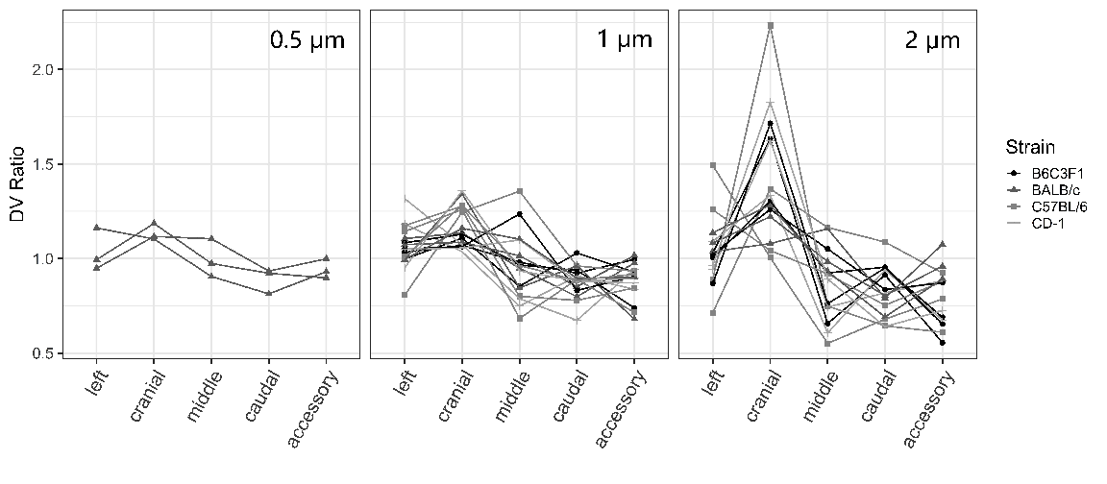

**Figure 1.**  add legend

Data showed in Figure 1 and Table 2 compare well with previous studies in rodents. Brain and colleagues (Environ Res 11:3) delivered aerosol (MMAD=1.6 µm) to both Syrian golden hamsters and Sprague Dawley rats in animal exposure chambers and determined the distribution of deposited particles through the evenness index (EI) defined as the ratio between normalized lobar deposition and normalized lobe weight (Figure 2A). In both species, the EI was larger than one in the cranial lobe (EI = 1.42 in hamsters and EI = 1.51 in rats) while EI in the left lobe was close to one (EI = 0.98 in hamsters and EI=1 in rats). In rats, they also observed an EI < 1 in the right middle, right accessory and right caudal lobes. Morgan et al. (1983 Rad research) exposed SAS/4 mice to 239PuO2 particles with a median aerodynamic diameter of 0.8, 1.5 and 2.2 µm. They observed EI larger than 1 in the cranial lobe and EI < 1 in the caudal and accessory lobe, with deviations from one increasing with increasing particle sizes, in agreement with data from this study (Table 2). Finally, in a more recent study, Yang and colleagues (ACS nano paper) delivered a liquid aerosol with a volume median diameter of 3.5 µm by mechanical ventilation in C57J/6 mice. Even though the particle size was larger than those used in this study, the DV ratio in each lobe show similar behavior as those observed in the C57J/6 mice included in this study (Figure 2B).

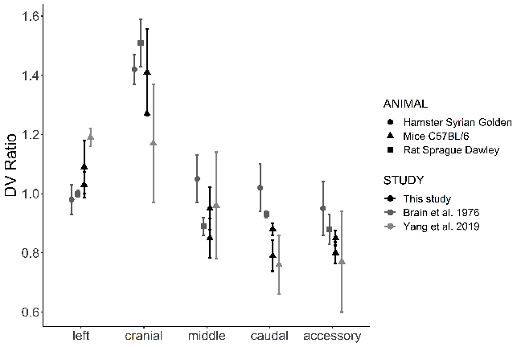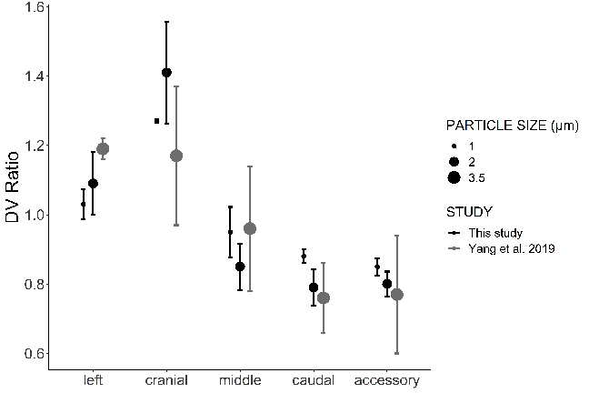

**Figure 2.** Add legend

The distribution of deposited particles in the lung is closely linked to the distribution of inhaled air among the different regions of the lungs (Bennett et al, 2002, Moller et al., 2009). In humans (Milic-emili, JAP 1966) and large animals such as horses (Amis 1984), the dependent lung region gets proportionally a larger fraction of a tidal breath than the nondependent lung regions. In contrast, in small animals such as the rat, the non-dependent lung region has been reported to be better ventilated than the dependent lung region (Rooney et al., Physiol Meas 30, 2009). This may explain the higher relative deposition in the non-dependent (cranial) than in the dependent lobes of the right lung (accessory and caudal) of rodents.

*3.1 Near-acini deposition:*

The shape of the distribution of near-acini deposition was also affected by particle size. Mice exposed to small aerosol particles (0.5 µm) tended to have a narrow, i.e. homogeneous, distribution (Figure 3, left panel). On the contrary, for mice exposed to larger aerosol particles (1 and 2 µm), the distribution of near-acini deposition tended to be wider, indicating an increase in heterogeneity of near-acini deposition with increasing particle size (Figure 3, middle and right panel).

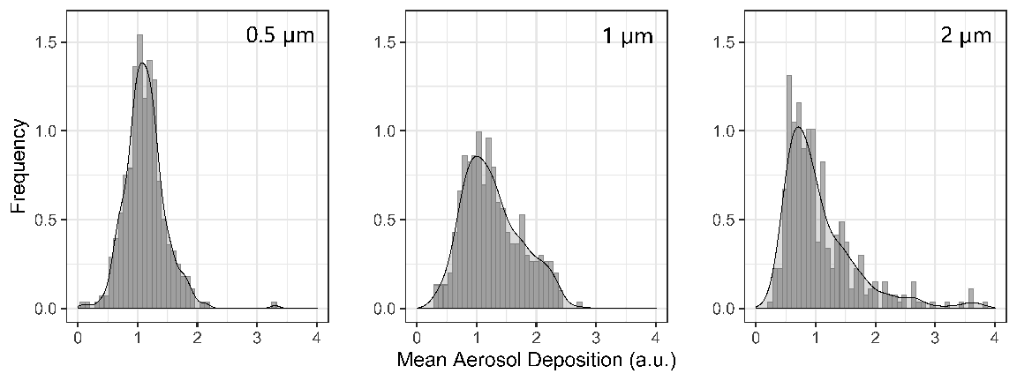

**Figure 3.** Add legend

The distributions of near-acini deposition were characterized by their standard deviation (SD) and skew (Sk). Individual data for all 33 mice samples are plotted in Figure 4 against particle size. Median, quartiles (box) and 95% intervals (vertical line) are also displayed in the figures. Both standard deviation and skew significantly increased with increasing particle size. The rather small standard deviation of near-acini deposition for 0.5 µm particles indicates a homogeneous deposition throughout the lung for these small particles. These results also suggest that the homogenous deposition observed at the lobar level still occur at the near-acini level.

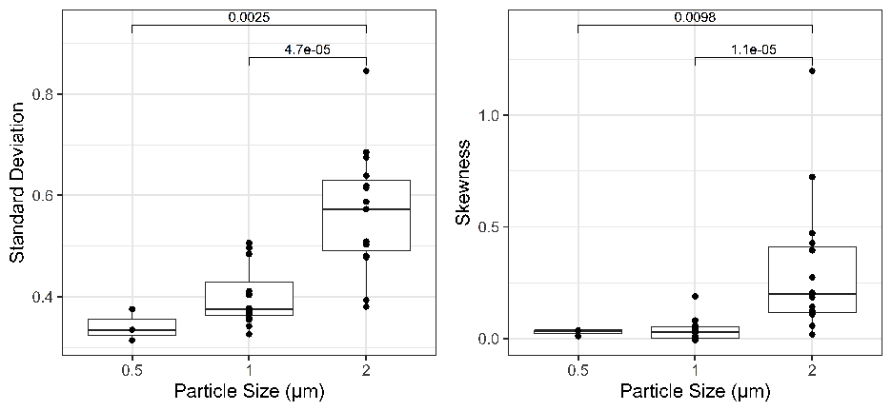

**Figure 4.** Add legend

For all mice and particle size, skew was positive, i.e. the distribution was right-skewed. It has been previously shown that the larger the skew is, the more “hot spots” there are, i.e. the more there are near-acini units with higher particle deposition (hot spots) than expected from a normal distribution (Darquenne et al. 2013 Clearance paper). Previous studies in humans showed that skew was inversely correlated with alveolar deposition (Garrard et al., 1981), implying that high values of skew are indicative of hot spots of deposited particles occurring predominantly in the bronchial airways. To our knowledge, there are no reports of skew of deposition distribution in rodents. Figure 5 displays the location of the top 1% of near-acini deposition relative to the airway tree structure for mice exposed to 0.5 (left), 1 (middle) and 2 µm particles (right panel). The data shown in Figure 5 are from the same BALB/c mice as those used in Figure 3 but similar distributions of hot spots were found in all of the 33 samples. Interestingly, the hot spots, while located relatively centrally, were only present in the apical region of the lungs, i.e. in the right cranial lobe and in the upper portion of the left lobe. These observations may explain the higher deposition measured in the right cranial lobe (Figure 1). As discussed above, the non-dependent region of the rodent lung is better ventilated than the dependent region. Because there is no major difference in the diameter of the airway of a given generation between lobes (data not shown), higher ventilation in the apical region of the lung results in higher velocities in the airways from the apical region than in similar airways located at the base of the lung. These high velocities increase the probability of a particle depositing by inertial impaction at airway bifurcation and thus increase the potential for the generation of hot spots. Indeed, of the three main mechanisms of aerosol deposition in the lung (inertial impaction, gravitational sedimentation and Brownian diffusion), inertial impaction is the only velocity-dependent mechanism (Darquenne, JAMP 2012).

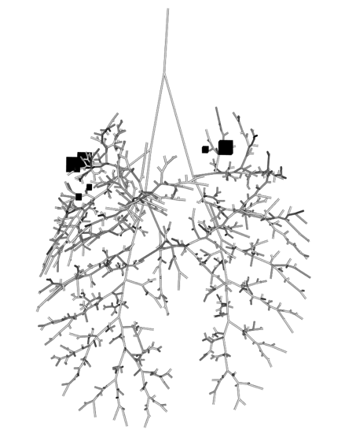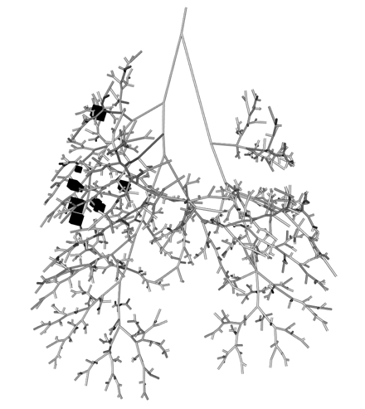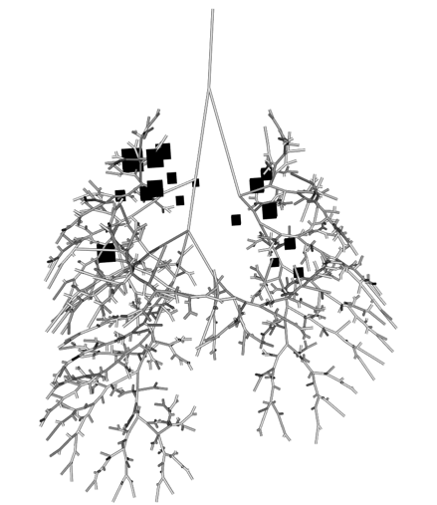

**Figure 5.** Add legend

Thought to consider: as apical regions of the lung are better ventilated than the bottom region, wouldn’t we expect a gradient of deposition from top to bottom in the near acini deposition datasets? We can discuss on Monday.

**4. CONCLUSION (needs work)**

Analysis was performed on the newly available lapdMouse database to determine the special heterogeneity of aerosol deposition at lobar scale and near-acini scale. There was an uneven distribution of deposited particles among the lobes of the mouse lung. Particularly, the cranial lobe receives higher deposition comparing to its volume, and caudal and accessory lobes receive lower deposition. The unevenness increased with increasing particle size (0.5 – 2 µm). Thus, depending on the lobe, individual lobe analysis to determine overall deposition may either underestimate or overestimate total lung burden, at least for particles in the micron size range. At near acini level, larger particle size was associated with higher likeness of formation of hot spots and a less uniform spatial distribution of particle deposition.

**ACKNOWLEDGEMENTS**

The study was partially funded by U01ES028669 from NIEHS at NIH.

**REFERENCES**

To be done when manuscript is finalized.